
PICTURE | EAN | BRAND | STYLE | PART | COLOR | COLOR  DESCRIPTION | DESCRIPTION | GENDER | SIZE | QTY | RETAIL PRICE | RETAIL AMOUNT | MADE IN | COMPOSITION | HS CODE
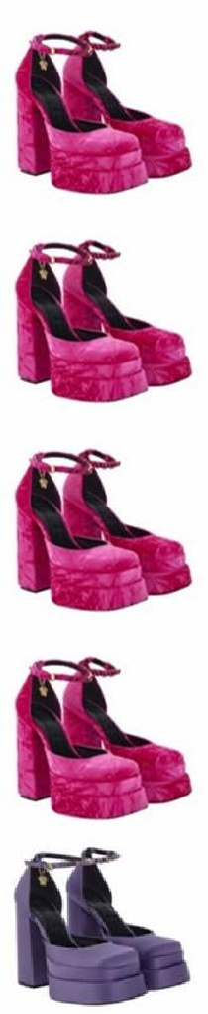  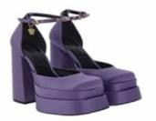 | 8054712734885 | VERSACE | 1002005 | 1A06465 | 1PK3V | Glossy Pink- Versace Gold/ | SCARPA DONNA / LADY PUMP | DONNA | 39 | 21 | € 1.190,00 | € 24.990,00 | MADE IN ITALY | UPPER 62% PL 32% CO 6% EA SOLE LEATHER | 64029998
 | 8054712734861 | VERSACE | 1002005 | 1A06465 | 1PK3V | Glossy Pink- Versace Gold/ | SCARPA DONNA / LADY PUMP | DONNA | 40 | 34 | € 1.190,00 | € 40.460,00 | MADE IN ITALY | UPPER 62% PL 32% CO 6% EA SOLE LEATHER | 64029998
 | 8054712734854 | VERSACE | 1002005 | 1A06465 | 1PK3V | Glossy Pink- Versace Gold/ | SCARPA DONNA / LADY PUMP | DONNA | 40+ | 2 | € 1.190,00 | € 2.380,00 | MADE IN ITALY | UPPER 62% PL 32% CO 6% EA SOLE LEATHER | 64029998
 | 8054712735097 | VERSACE | 1002005 | 1A06465 | 1PK3V | Glossy Pink- Versace Gold/ | SCARPA DONNA / LADY PUMP | DONNA | 41 | 2 | € 1.190,00 | € 2.380,00 | MADE IN ITALY | UPPER 62% PL 32% CO 6% EA SOLE LEATHER | 64029998
 | 8052045783730 | VERSACE | 1002005 | DRA67 | 1L72V | Orchid-Versace Gold/ | SCARPA DONNA / LADY SHOES | DONNA | 35 | 3 | € 1.190,00 | € 3.570,00 | MADE IN ITALY | UPPER 72% VISCOSE 28% SILK LINING 100% CPS SOLE CALF LEATHER | 64042090
 | 8052045783747 | VERSACE | 1002005 | DRA67 | 1L72V | Orchid-Versace Gold/ | SCARPA DONNA / LADY SHOES | DONNA | 35+ | 6 | € 1.190,00 | € 7.140,00 | MADE IN ITALY | UPPER 72% VISCOSE 28% SILK LINING 100% CPS SOLE CALF LEATHER | 64042090
 | 8052045783723 | VERSACE | 1002005 | DRA67 | 1L72V | Orchid-Versace Gold/ | SCARPA DONNA / LADY SHOES | DONNA | 36 | 71 | € 1.190,00 | € 84.490,00 | MADE IN ITALY | UPPER 72% VISCOSE 28% SILK LINING 100% CPS SOLE CALF LEATHER | 64042090
 | 8052045783716 | VERSACE | 1002005 | DRA67 | 1L72V | Orchid-Versace Gold/ | SCARPA DONNA / LADY SHOES | DONNA | 36+ | 37 | € 1.190,00 | € 44.030,00 | MADE IN ITALY | UPPER 72% VISCOSE 28% SILK LINING 100% CPS SOLE CALF LEATHER | 64042090
 | 8052045783709 | VERSACE | 1002005 | DRA67 | 1L72V | Orchid-Versace Gold/ | SCARPA DONNA / LADY SHOES | DONNA | 37 | 152 | € 1.190,00 | € 180.880,00 | MADE IN ITALY | UPPER 72% VISCOSE 28% SILK LINING 100% CPS SOLE CALF LEATHER | 64042090
 | 8052045783693 | VERSACE | 1002005 | DRA67 | 1L72V | Orchid-Versace Gold/ | SCARPA DONNA / LADY SHOES | DONNA | 37+ | 33 | € 1.190,00 | € 39.270,00 | MADE IN ITALY | UPPER 72% VISCOSE 28% SILK LINING 100% CPS SOLE CALF LEATHER | 64042090
 | 8052045783686 | VERSACE | 1002005 | DRA67 | 1L72V | Orchid-Versace Gold/ | SCARPA DONNA / LADY SHOES | DONNA | 38 | 289 | € 1.190,00 | € 343.910,00 | MADE IN ITALY | UPPER 72% VISCOSE 28% SILK LINING 100% CPS SOLE CALF LEATHER | 64042090

PICTURE | EAN | BRAND | STYLE | PART | COLOR | COLOR  DESCRIPTION | DESCRIPTION | GENDER | SIZE | QTY | RETAIL PRICE | RETAIL AMOUNT | MADE IN | COMPOSITION | HS CODE
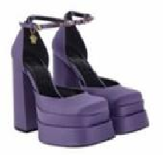  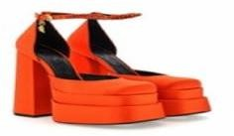 | 8052045783679 | VERSACE | 1002005 | DRA67 | 1L72V | Orchid-Versace Gold/ | SCARPA DONNA / LADY SHOES | DONNA | 38+ | 37 | € 1.190,00 | € 44.030,00 | MADE IN ITALY | UPPER 72% VISCOSE 28% SILK LINING 100% CPS SOLE CALF LEATHER | 64042090
 | 8052045783662 | VERSACE | 1002005 | DRA67 | 1L72V | Orchid-Versace Gold/ | SCARPA DONNA / LADY SHOES | DONNA | 39 | 87 | € 1.190,00 | € 103.530,00 | MADE IN ITALY | UPPER 72% VISCOSE 28% SILK LINING 100% CPS SOLE CALF LEATHER | 64042090
 | 8052045783655 | VERSACE | 1002005 | DRA67 | 1L72V | Orchid-Versace Gold/ | SCARPA DONNA / LADY SHOES | DONNA | 39+ | 13 | € 1.190,00 | € 15.470,00 | MADE IN ITALY | UPPER 72% VISCOSE 28% SILK LINING 100% CPS SOLE CALF LEATHER | 64042090
 | 8052045783648 | VERSACE | 1002005 | DRA67 | 1L72V | Orchid-Versace Gold/ | SCARPA DONNA / LADY SHOES | DONNA | 40 | 4 | € 1.190,00 | € 4.760,00 | MADE IN ITALY | UPPER 72% VISCOSE 28% SILK LINING 100% CPS SOLE CALF LEATHER | 64042090
 | 8054712079962 | VERSACE | 1002005 | DRA67 | 1L72V | Orchid-Versace Gold/ | SCARPA DONNA / LADY SHOES | DONNA | 40+ | 5 | € 1.190,00 | € 5.950,00 | MADE IN ITALY | UPPER 72% VISCOSE 28% SILK LINING 100% CPS SOLE CALF LEATHER | 64042090
 | 8052045783631 | VERSACE | 1002005 | DRA67 | 1L72V | Orchid-Versace Gold/ | SCARPA DONNA / LADY SHOES | DONNA | 41 | 14 | € 1.190,00 | € 16.660,00 | MADE IN ITALY | UPPER 72% VISCOSE 28% SILK LINING 100% CPS SOLE CALF LEATHER | 64042090
 | 8054712623097 | VERSACE | 1002005 | DRA67 | 1O67V | Neon Orange- Versace Gold/ | SCARPA DONNA / LADY SHOES | DONNA | 36 | 5 | € 1.190,00 | € 5.950,00 | MADE IN ITALY | UPPER 72% VISCOSE 28% SILK LINING 100% CPS SOLE CALF LEATHER | 64042090
 | 8054712621192 | VERSACE | 1002005 | DRA67 | 1O67V | Neon Orange- Versace Gold/ | SCARPA DONNA / LADY SHOES | DONNA | 37 | 37 | € 1.190,00 | € 44.030,00 | MADE IN ITALY | UPPER 72% VISCOSE 28% SILK LINING 100% CPS SOLE CALF LEATHER | 64042090
 | 8054712623103 | VERSACE | 1002005 | DRA67 | 1O67V | Neon Orange- Versace Gold/ | SCARPA DONNA / LADY SHOES | DONNA | 37+ | 12 | € 1.190,00 | € 14.280,00 | MADE IN ITALY | UPPER 72% VISCOSE 28% SILK LINING 100% CPS SOLE CALF LEATHER | 64042090
 | 8054712621208 | VERSACE | 1002005 | DRA67 | 1O67V | Neon Orange- Versace Gold/ | SCARPA DONNA / LADY SHOES | DONNA | 38 | 45 | € 1.190,00 | € 53.550,00 | MADE IN ITALY | UPPER 72% VISCOSE 28% SILK LINING 100% CPS SOLE CALF LEATHER | 64042090
 | 8054712623110 | VERSACE | 1002005 | DRA67 | 1O67V | Neon Orange- Versace Gold/ | SCARPA DONNA / LADY SHOES | DONNA | 38+ | 19 | € 1.190,00 | € 22.610,00 | MADE IN ITALY | UPPER 72% VISCOSE 28% SILK LINING 100% CPS SOLE CALF LEATHER | 64042090
 | 8054712621215 | VERSACE | 1002005 | DRA67 | 1O67V | Neon Orange- Versace Gold/ | SCARPA DONNA / LADY SHOES | DONNA | 39 | 39 | € 1.190,00 | € 46.410,00 | MADE IN ITALY | UPPER 72% VISCOSE 28% SILK LINING 100% CPS SOLE CALF LEATHER | 64042090

PICTURE | EAN | BRAND | STYLE | PART | COLOR | COLOR  DESCRIPTION | DESCRIPTION | GENDER | SIZE | QTY | RETAIL PRICE | RETAIL AMOUNT | MADE IN | COMPOSITION | HS CODE
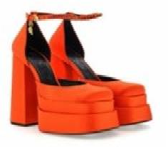  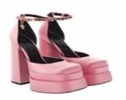  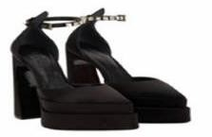 | 8054712621222 | VERSACE | 1002005 | DRA67 | 1O67V | Neon Orange- Versace Gold/ | SCARPA DONNA / LADY SHOES | DONNA | 40 | 16 | € 1.190,00 | € 19.040,00 | MADE IN ITALY | UPPER 72% VISCOSE 28% SILK LINING 100% CPS SOLE CALF LEATHER | 64042090
 | 8054712621239 | VERSACE | 1002005 | DRA67 | 1O67V | Neon Orange- Versace Gold/ | SCARPA DONNA / LADY SHOES | DONNA | 41 | 2 | € 1.190,00 | € 2.380,00 | MADE IN ITALY | UPPER 72% VISCOSE 28% SILK LINING 100% CPS SOLE CALF LEATHER | 64042090
 | 8052045783853 | VERSACE | 1002005 | DRA67 | 1PB9V | Candy-Oro Versace/ | SCARPA DONNA / LADY SHOES | DONNA | 35 | 2 | € 1.190,00 | € 2.380,00 | MADE IN ITALY | UPPER 72% VISCOSE 28% SILK LINING 100% CPS SOLE CALF LEATHER | 64042090
 | 8052045783846 | VERSACE | 1002005 | DRA67 | 1PB9V | Candy-Oro Versace/ | SCARPA DONNA / LADY SHOES | DONNA | 36 | 4 | € 1.190,00 | € 4.760,00 | MADE IN ITALY | UPPER 72% VISCOSE 28% SILK LINING 100% CPS SOLE CALF LEATHER | 64042090
 | 8052045783822 | VERSACE | 1002005 | DRA67 | 1PB9V | Candy-Oro Versace/ | SCARPA DONNA / LADY SHOES | DONNA | 37 | 22 | € 1.190,00 | € 26.180,00 | MADE IN ITALY | UPPER 72% VISCOSE 28% SILK LINING 100% CPS SOLE CALF LEATHER | 64042090
 | 8052045783808 | VERSACE | 1002005 | DRA67 | 1PB9V | Candy-Oro Versace/ | SCARPA DONNA / LADY SHOES | DONNA | 38 | 39 | € 1.190,00 | € 46.410,00 | MADE IN ITALY | UPPER 72% VISCOSE 28% SILK LINING 100% CPS SOLE CALF LEATHER | 64042090
 | 8052045783785 | VERSACE | 1002005 | DRA67 | 1PB9V | Candy-Oro Versace/ | SCARPA DONNA / LADY SHOES | DONNA | 39 | 46 | € 1.190,00 | € 54.740,00 | MADE IN ITALY | UPPER 72% VISCOSE 28% SILK LINING 100% CPS SOLE CALF LEATHER | 64042090
 | 8052045783778 | VERSACE | 1002005 | DRA67 | 1PB9V | Candy-Oro Versace/ | SCARPA DONNA / LADY SHOES | DONNA | 39+ | 5 | € 1.190,00 | € 5.950,00 | MADE IN ITALY | UPPER 72% VISCOSE 28% SILK LINING 100% CPS SOLE CALF LEATHER | 64042090
 | 8052045783761 | VERSACE | 1002005 | DRA67 | 1PB9V | Candy-Oro Versace/ | SCARPA DONNA / LADY SHOES | DONNA | 40 | 30 | € 1.190,00 | € 35.700,00 | MADE IN ITALY | UPPER 72% VISCOSE 28% SILK LINING 100% CPS SOLE CALF LEATHER | 64042090
 | 8054712409356 | VERSACE | 1002005 | DRA67 | 1PB9V | Candy-Oro Versace/ | SCARPA DONNA / LADY SHOES | DONNA | 40+ | 7 | € 1.190,00 | € 8.330,00 | MADE IN ITALY | UPPER 72% VISCOSE 28% SILK LINING 100% CPS SOLE CALF LEATHER | 64042090
 | 8052045783754 | VERSACE | 1002005 | DRA67 | 1PB9V | Candy-Oro Versace/ | SCARPA DONNA / LADY SHOES | DONNA | 41 | 6 | € 1.190,00 | € 7.140,00 | MADE IN ITALY | UPPER 72% VISCOSE 28% SILK LINING 100% CPS SOLE CALF LEATHER | 64042090
 | 8054712606243 | VERSACE | 1006899 | 1A00868 | 1B00V | Black-Versace Gold/ | SCARPA DONNA / SHOES- SATIN+STRASS SHOES- RASO+STRASS | DONNA | 40 | 6 | € 1.190,00 | € 7.140,00 | MADE IN ITALY | 72% VI 28% SE | 64042090

PICTURE | EAN | BRAND | STYLE | PART | COLOR | COLOR  DESCRIPTION | DESCRIPTION | GENDER | SIZE | QTY | RETAIL PRICE | RETAIL AMOUNT | MADE IN | COMPOSITION | HS CODE
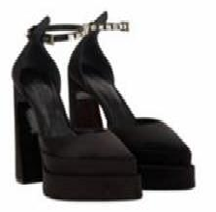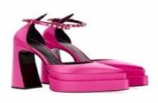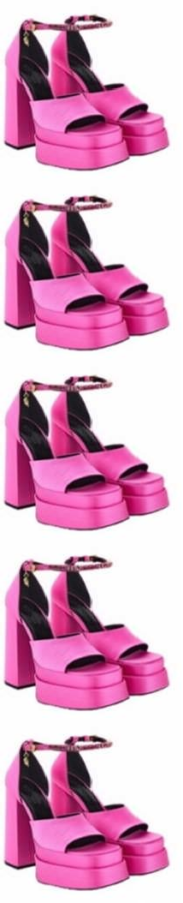 | 8054712621932 | VERSACE | 1006899 | 1A00868 | 1B00V | Black-Versace Gold/ | SCARPA DONNA / SHOES- SATIN+STRASS SHOES- RASO+STRASS | DONNA | 40+ | 4 | € 1.190,00 | € 4.760,00 | MADE IN ITALY | 72% VI 28% SE | 64042090
 | 8054712621949 | VERSACE | 1006899 | 1A00868 | 1B00V | Black-Versace Gold/ | SCARPA DONNA / SHOES- SATIN+STRASS SHOES- RASO+STRASS | DONNA | 41 | 3 | € 1.190,00 | € 3.570,00 | MADE IN ITALY | 72% VI 28% SE | 64042090
 | 8054712621536 | VERSACE | 1006899 | 1A00868 | 1PI3V | Pink Lemonade- Versace Gold/ | SCARPA DONNA / SHOES- SATIN+STRASS SHOES- RASO+STRASS | DONNA | 36+ | 2 | € 1.190,00 | € 2.380,00 | MADE IN ITALY | 72% VI 28% SE | 64042090
 | 8054712621338 | VERSACE | 1006899 | 1A00868 | 1PI3V | Pink Lemonade- Versace Gold/ | SCARPA DONNA / SHOES- SATIN+STRASS SHOES- RASO+STRASS | DONNA | 38 | 3 | € 1.190,00 | € 3.570,00 | MADE IN ITALY | 72% VI 28% SE | 64042090
 | 8054712621550 | VERSACE | 1006899 | 1A00868 | 1PI3V | Pink Lemonade- Versace Gold/ | SCARPA DONNA / SHOES- SATIN+STRASS SHOES- RASO+STRASS | DONNA | 38+ | 3 | € 1.190,00 | € 3.570,00 | MADE IN ITALY | 72% VI 28% SE | 64042090
 | 8054712621529 | VERSACE | 1006899 | 1A00868 | 1PI3V | Pink Lemonade- Versace Gold/ | SCARPA DONNA / SHOES- SATIN+STRASS SHOES- RASO+STRASS | DONNA | 40 | 6 | € 1.190,00 | € 7.140,00 | MADE IN ITALY | 72% VI 28% SE | 64042090
 | 8054712622045 | VERSACE | 1006899 | 1A00868 | 1PI3V | Pink Lemonade- Versace Gold/ | SCARPA DONNA / SHOES- SATIN+STRASS SHOES- RASO+STRASS | DONNA | 41 | 6 | € 1.190,00 | € 7.140,00 | MADE IN ITALY | 72% VI 28% SE | 64042090
 | 8054712916687 | VERSACE | 1007717 | DRA67 | 1PK4V | Pink Paradise- Versace Gold/ | SANDALO DONNA / LADY SANDALS | DONNA | 37 | 13 | € 1.190,00 | € 15.470,00 | MADE IN ITALY | UPPER 72% VISCOSE 28% SILK LINING 100% CPS SOLE CALF LEATHER | 64042090
 | 8054712916663 | VERSACE | 1007717 | DRA67 | 1PK4V | Pink Paradise- Versace Gold/ | SANDALO DONNA / LADY SANDALS | DONNA | 38 | 8 | € 1.190,00 | € 9.520,00 | MADE IN ITALY | UPPER 72% VISCOSE 28% SILK LINING 100% CPS SOLE CALF LEATHER | 64042090
 | 8054712916649 | VERSACE | 1007717 | DRA67 | 1PK4V | Pink Paradise- Versace Gold/ | SANDALO DONNA / LADY SANDALS | DONNA | 39 | 13 | € 1.190,00 | € 15.470,00 | MADE IN ITALY | UPPER 72% VISCOSE 28% SILK LINING 100% CPS SOLE CALF LEATHER | 64042090
 | 8054712916625 | VERSACE | 1007717 | DRA67 | 1PK4V | Pink Paradise- Versace Gold/ | SANDALO DONNA / LADY SANDALS | DONNA | 40 | 5 | € 1.190,00 | € 5.950,00 | MADE IN ITALY | UPPER 72% VISCOSE 28% SILK LINING 100% CPS SOLE CALF LEATHER | 64042090
 | 8054712916670 | VERSACE | 1007717 | DRA67 | 1PK4V | Pink Paradise- Versace Gold/ | SANDALO DONNA / LADY SANDALS | DONNA | 41 | 5 | € 1.190,00 | € 5.950,00 | MADE IN ITALY | UPPER 72% VISCOSE 28% SILK LINING 100% CPS SOLE CALF LEATHER | 64042090

PICTURE | EAN | BRAND | STYLE | PART | COLOR | COLOR  DESCRIPTION | DESCRIPTION | GENDER | SIZE | QTY | RETAIL PRICE | RETAIL AMOUNT | MADE IN | COMPOSITION | HS CODE
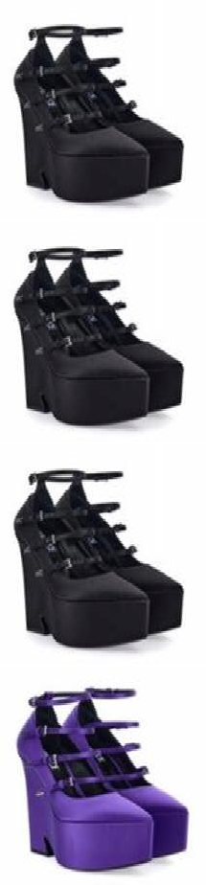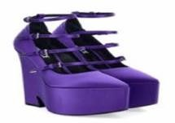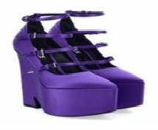 | 8056204159947 | VERSACE | 1009469 | 1A00619 | 1B00P | Black-Palladium/ | SCARPA DONNA / SHOES-SATIN SHOES-RASO | DONNA | 38 | 3 | € 1.190,00 | € 3.570,00 | MADE IN ITALY | 72% VI 28% SE | 64042090
 | 8056204159909 | VERSACE | 1009469 | 1A00619 | 1B00P | Black-Palladium/ | SCARPA DONNA / SHOES-SATIN SHOES-RASO | DONNA | 39 | 1 | € 1.190,00 | € 1.190,00 | MADE IN ITALY | 72% VI 28% SE | 64042090
 | 8056204159923 | VERSACE | 1009469 | 1A00619 | 1B00P | Black-Palladium/ | SCARPA DONNA / SHOES-SATIN SHOES-RASO | DONNA | 40 | 1 | € 1.190,00 | € 1.190,00 | MADE IN ITALY | 72% VI 28% SE | 64042090
 | 8056204160172 | VERSACE | 1009469 | 1A00619 | 1LD2P | Dark Orchid- Palladium/ | SCARPA DONNA / SHOES-SATIN SHOES-RASO | DONNA | 36 | 21 | € 1.190,00 | € 24.990,00 | MADE IN ITALY | 72% VI 28% SE | 64042090
 | 8056204160165 | VERSACE | 1009469 | 1A00619 | 1LD2P | Dark Orchid- Palladium/ | SCARPA DONNA / SHOES-SATIN SHOES-RASO | DONNA | 36+ | 11 | € 1.190,00 | € 13.090,00 | MADE IN ITALY | 72% VI 28% SE | 64042090
 | 8056204160158 | VERSACE | 1009469 | 1A00619 | 1LD2P | Dark Orchid- Palladium/ | SCARPA DONNA / SHOES-SATIN SHOES-RASO | DONNA | 37 | 35 | € 1.190,00 | € 41.650,00 | MADE IN ITALY | 72% VI 28% SE | 64042090
 | 8056204160141 | VERSACE | 1009469 | 1A00619 | 1LD2P | Dark Orchid- Palladium/ | SCARPA DONNA / SHOES-SATIN SHOES-RASO | DONNA | 37+ | 22 | € 1.190,00 | € 26.180,00 | MADE IN ITALY | 72% VI 28% SE | 64042090
 | 8056204160196 | VERSACE | 1009469 | 1A00619 | 1LD2P | Dark Orchid- Palladium/ | SCARPA DONNA / SHOES-SATIN SHOES-RASO | DONNA | 38 | 38 | € 1.190,00 | € 45.220,00 | MADE IN ITALY | 72% VI 28% SE | 64042090
 | 8056204160127 | VERSACE | 1009469 | 1A00619 | 1LD2P | Dark Orchid- Palladium/ | SCARPA DONNA / SHOES-SATIN SHOES-RASO | DONNA | 38+ | 20 | € 1.190,00 | € 23.800,00 | MADE IN ITALY | 72% VI 28% SE | 64042090
 | 8056204160110 | VERSACE | 1009469 | 1A00619 | 1LD2P | Dark Orchid- Palladium/ | SCARPA DONNA / SHOES-SATIN SHOES-RASO | DONNA | 39 | 36 | € 1.190,00 | € 42.840,00 | MADE IN ITALY | 72% VI 28% SE | 64042090
 | 8056204160103 | VERSACE | 1009469 | 1A00619 | 1LD2P | Dark Orchid- Palladium/ | SCARPA DONNA / SHOES-SATIN SHOES-RASO | DONNA | 39+ | 6 | € 1.190,00 | € 7.140,00 | MADE IN ITALY | 72% VI 28% SE | 64042090
 | 8056204160097 | VERSACE | 1009469 | 1A00619 | 1LD2P | Dark Orchid- Palladium/ | SCARPA DONNA / SHOES-SATIN SHOES-RASO | DONNA | 40 | 12 | € 1.190,00 | € 14.280,00 | MADE IN ITALY | 72% VI 28% SE | 64042090

PICTURE | EAN | BRAND | STYLE | PART | COLOR | COLOR  DESCRIPTION | DESCRIPTION | GENDER | SIZE | QTY | RETAIL PRICE | RETAIL AMOUNT | MADE IN | COMPOSITION | HS CODE
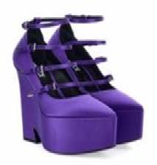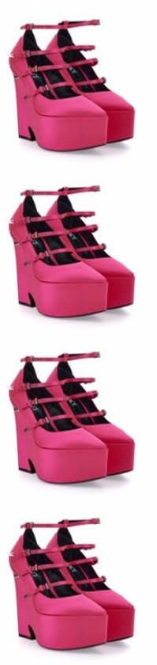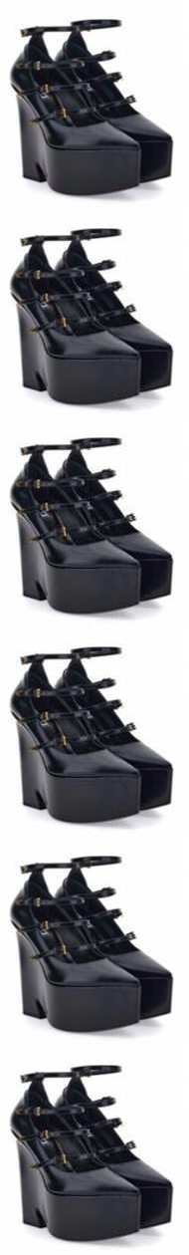 | 8056204160080 | VERSACE | 1009469 | 1A00619 | 1LD2P | Dark Orchid- Palladium/ | SCARPA DONNA / SHOES-SATIN SHOES-RASO | DONNA | 40+ | 2 | € 1.190,00 | € 2.380,00 | MADE IN ITALY | 72% VI 28% SE | 64042090
 | 8056204160400 | VERSACE | 1009469 | 1A00619 | 1PM6P | Tropical Pink- Palladium/ | SCARPA DONNA / SHOES-SATIN SHOES-RASO | DONNA | 36 | 19 | € 1.190,00 | € 22.610,00 | MADE IN ITALY | 72% VI 28% SE | 64042090
 | 8056204160387 | VERSACE | 1009469 | 1A00619 | 1PM6P | Tropical Pink- Palladium/ | SCARPA DONNA / SHOES-SATIN SHOES-RASO | DONNA | 37 | 41 | € 1.190,00 | € 48.790,00 | MADE IN ITALY | 72% VI 28% SE | 64042090
 | 8056204157653 | VERSACE | 1009469 | 1A00619 | 1PM6P | Tropical Pink- Palladium/ | SCARPA DONNA / SHOES-SATIN SHOES-RASO | DONNA | 38 | 46 | € 1.190,00 | € 54.740,00 | MADE IN ITALY | 72% VI 28% SE | 64042090
 | 8056204160356 | VERSACE | 1009469 | 1A00619 | 1PM6P | Tropical Pink- Palladium/ | SCARPA DONNA / SHOES-SATIN SHOES-RASO | DONNA | 39 | 21 | € 1.190,00 | € 24.990,00 | MADE IN ITALY | 72% VI 28% SE | 64042090
 | 8056204157783 | VERSACE | 1009469 | DVT51 | 1B00V | Black-Versace Gold/ | SCARPA DONNA / SHOES-CALF ABRASIVATO SHOES-VITELLO ABRASIVATO | DONNA | 37 | 9 | € 1.190,00 | € 10.710,00 | MADE IN ITALY | 100% VL | 64035999
 | 8056204157776 | VERSACE | 1009469 | DVT51 | 1B00V | Black-Versace Gold/ | SCARPA DONNA / SHOES-CALF ABRASIVATO SHOES-VITELLO ABRASIVATO | DONNA | 37+ | 3 | € 1.190,00 | € 3.570,00 | MADE IN ITALY | 100% VL | 64035999
 | 8056204157660 | VERSACE | 1009469 | DVT51 | 1B00V | Black-Versace Gold/ | SCARPA DONNA / SHOES-CALF ABRASIVATO SHOES-VITELLO ABRASIVATO | DONNA | 38 | 18 | € 1.190,00 | € 21.420,00 | MADE IN ITALY | 100% VL | 64035999
 | 8056204160813 | VERSACE | 1009469 | DVT51 | 1B00V | Black-Versace Gold/ | SCARPA DONNA / SHOES-CALF ABRASIVATO SHOES-VITELLO ABRASIVATO | DONNA | 38+ | 3 | € 1.190,00 | € 3.570,00 | MADE IN ITALY | 100% VL | 64035999
 | 8056204160820 | VERSACE | 1009469 | DVT51 | 1B00V | Black-Versace Gold/ | SCARPA DONNA / SHOES-CALF ABRASIVATO SHOES-VITELLO ABRASIVATO | DONNA | 39 | 13 | € 1.190,00 | € 15.470,00 | MADE IN ITALY | 100% VL | 64035999
 | 8056204160837 | VERSACE | 1009469 | DVT51 | 1B00V | Black-Versace Gold/ | SCARPA DONNA / SHOES-CALF ABRASIVATO SHOES-VITELLO ABRASIVATO | DONNA | 39+ | 3 | € 1.190,00 | € 3.570,00 | MADE IN ITALY | 100% VL | 64035999
1.607 |  |  |  |  |  |  |  |  |  |  | € 1.912.330,00

